OCI Generative AI Service:

It is a **fully managed service** that provides a set of customizable Large Language Models(LLMs) available via a single API to build generative AI applications.(You dont have to manage any infra structure).

what single API access means is that you have the flexibility to use different foundational models with minimal code changes.

- The service also provides a **choice of models**. We have high performing, pre-trained foundational models available from meta and cohere.

- The service also enables flexible **fine-tuning**, where you can create custom models by fine-tuning foundational models with your own dataset.

- And finally, the service enables dedicated **AI clusters**, which are GPU-based compute resources that can host your fine-tuning and inference workloads.

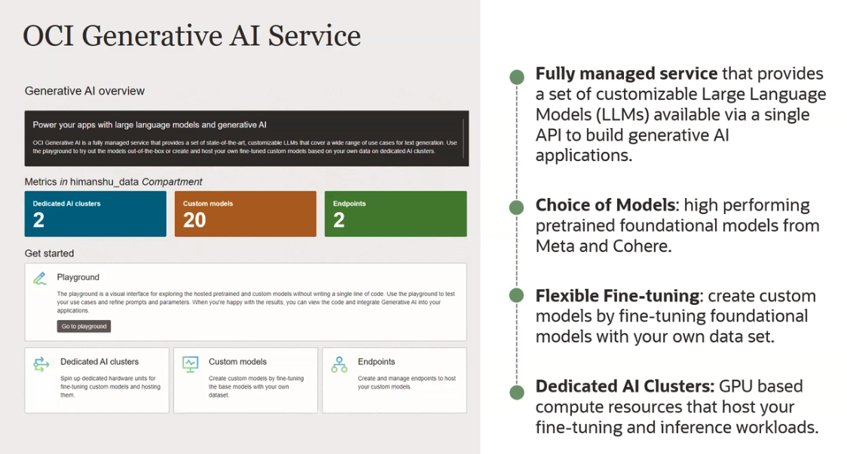

**How does the OCI generative service work?**

You provide text input in natural language to the model.

Eg: Generate a product pitch for a particular product. And the Gen AI service analyzes the user input and can generate, summarize, transform, extract information or classify text based on the request from the user. And then a response is sent back to the user.

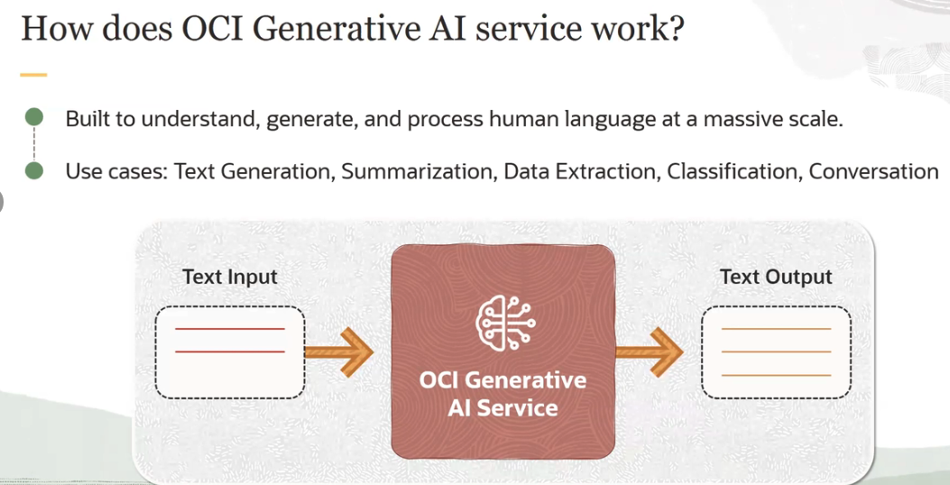

**\* Pre-Trained Fondational Models** which are made available by these service.

**First** category of models are **Generation models**: In these we have 3 models -

1. **Command model** from cohere, which is a highly performant instruction following conversational model. It has 52 billion parameters.

2. **Command light model** from cohere which is a smaller, faster version of command but almost as capable. It has 6 billion parameters.

3. **LLama-2 70 billion chat** model available from Meta.

And these models are instruction following models or instruction tuned models, where we take the base models and run them through additional training called instruction tuning. These allows the model to better follow human language instructions, such as generate a product pitch for a particular product.

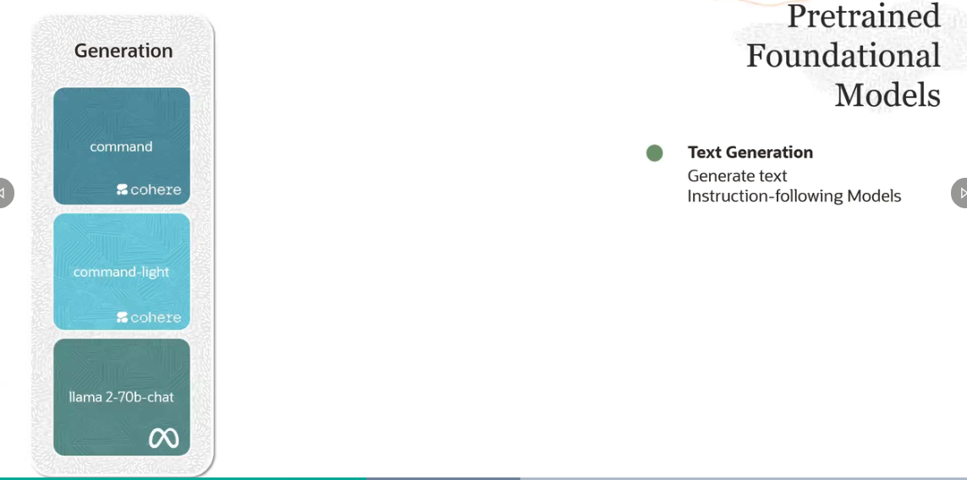

The **second** category of models which are available in the service are called **summarization models.**

And here, we have the command model available from cohere. And the idea with summarization model is that you can summarize text with your instructed format, length, and tone.

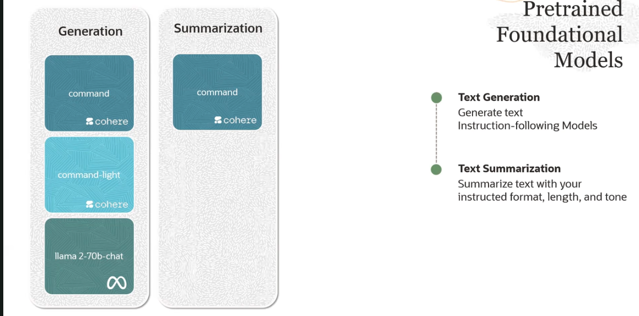

The **third** category of pre-trained foundational models which are available through the service are called **embedding models**.

- And here, we have embedding models from cohere. You see embed English model, embed multilingual models. And the idea behind these models are to create embeddings.

- Embeddings make it easy for computers to understand the relationship between pieces of text.

- Embeddings are nothing, but you take text and you convert them into vector of numbers.

- Embeddings are mostly used for semantic searches, where the search function focuses on the meaning of the text that it is searching through rather than finding results based on keyword.

- Another model you see here are the **multilingual models** from cohere. These multilingual models support 100 plus languages and can be used to search within a language. For example, search with a French query on French documents and across languages. For example, search with a French query on English documents.

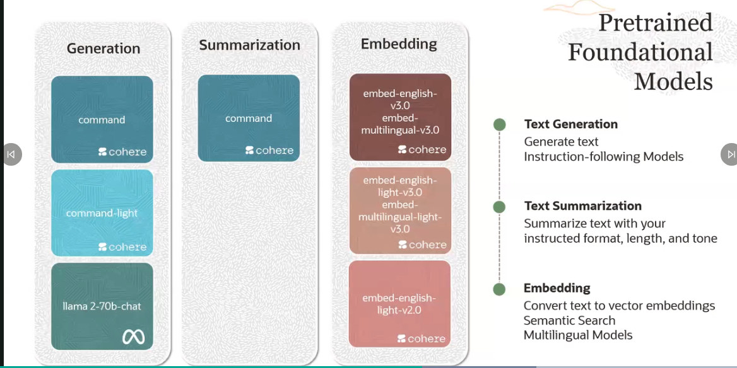

Key capabilities of the OCI generative AI service is the ability to fine-tune these models.

**Fine-tuning:** And what you do with fine-tuning is you optimize a pre-trained foundational model on a smaller domain-specific data set.

You have your own custom data, your own domain-specific data. And you take the pre-trained foundational model and you train that model with this custom data. And you end up with a custom model through this fine-tuning process.

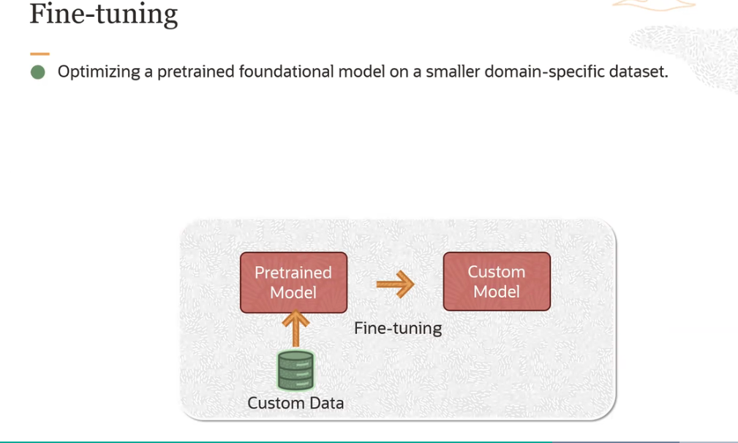

There are two benefits to doing fine-tuning.

1. You improve model performance on specific tasks. By tailoring the model to domain-specific data, it can better understand and generate contextually relevant responses.

2. You can improve model efficiency by reducing the number of tokens.

- **You use fine-tuning when a pre-trained model doesn't perform your task well or you want to teach it something new.**

- An OCI generative AI service uses the T-Few fine-tuning mechanism to enable fast and efficient customizations. T-Few is a parameter efficient fine-tuning technique where we update only a portion of model's weight.

- Doing so gives you results which have better accuracy at significantly lower cost.

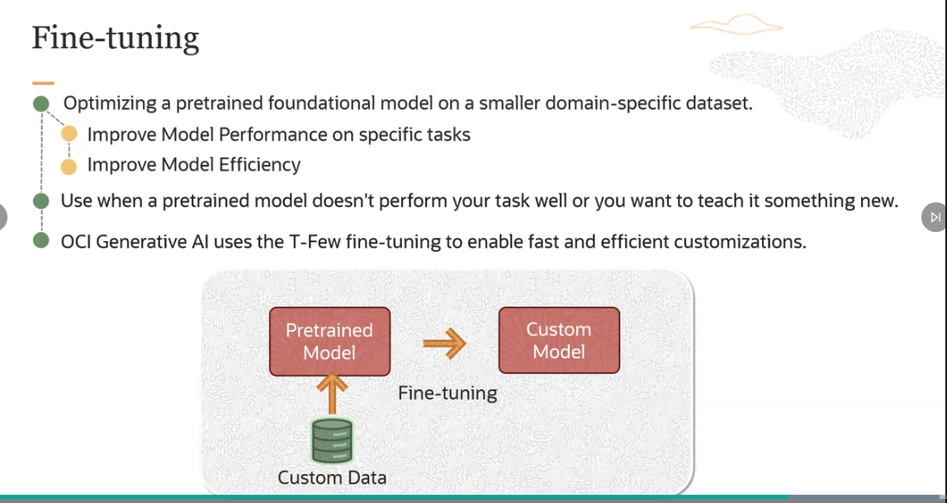

**Dedicated AI Clusters:**

Dedicated AI clusters are GPU-based compute resources that host the customers fine-tuning and inference workloads.

- The generative AI service establishes a dedicated cluster, which includes dedicated GPUs and an exclusive RDMA cluster network for connecting the GPUs.

- The GPUs allocated for a customer's generative tasks are isolated from other GPU.

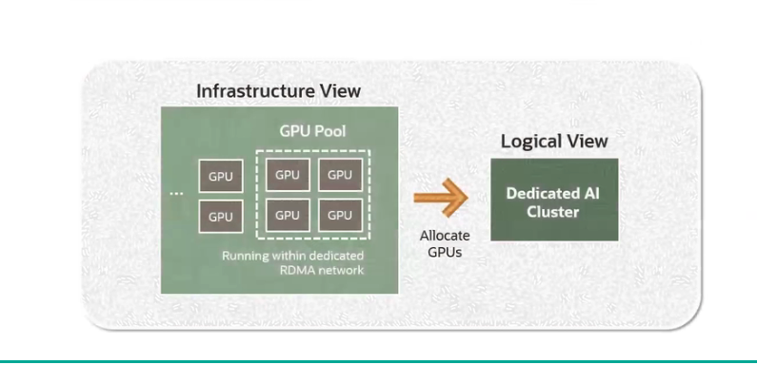

We pool a specific number of GPUs and make that pool available with a dedicated RDMA network. And that is called the dedicated AI cluster.

Demo

First, Logged on to the OCI console. And you can see, I'm in the US Midwest Chicago region. To access the service, I will click on the navigation menu, and click on Analytics and AI.

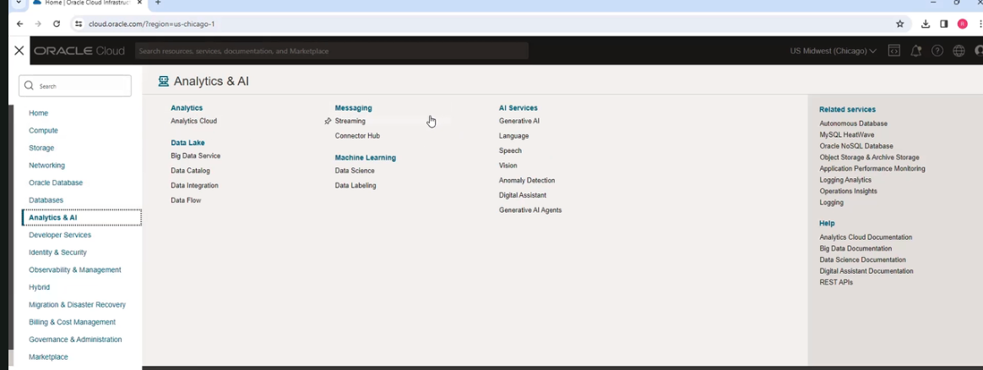

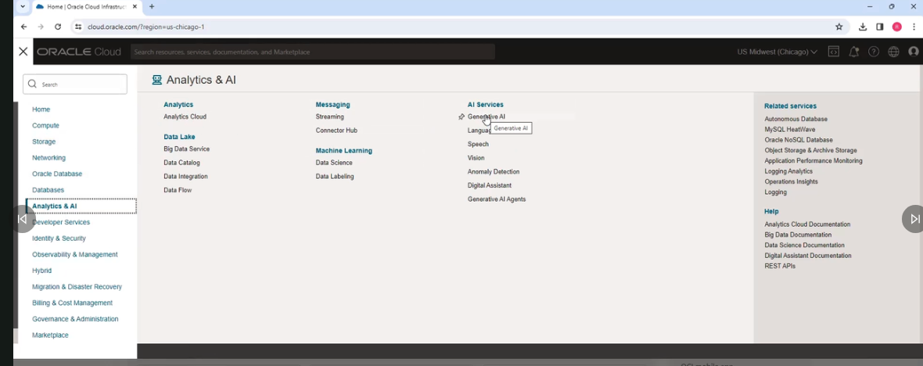

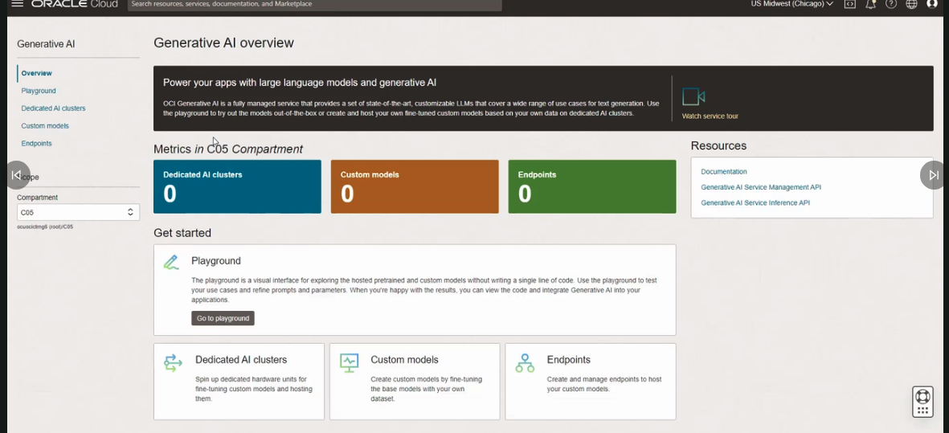

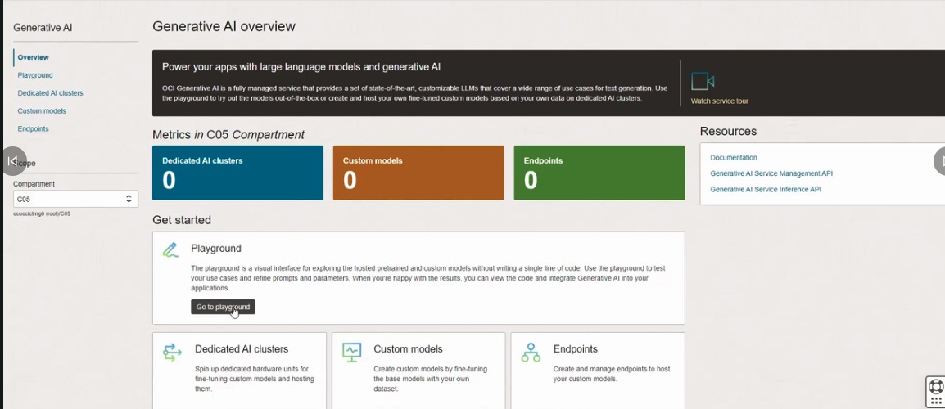

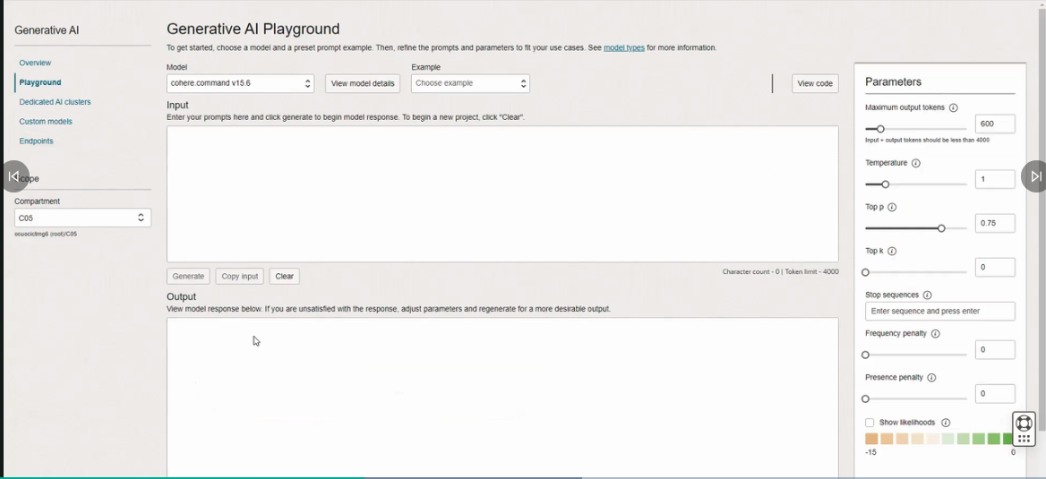

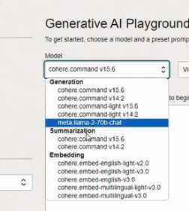 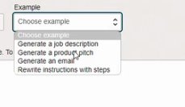

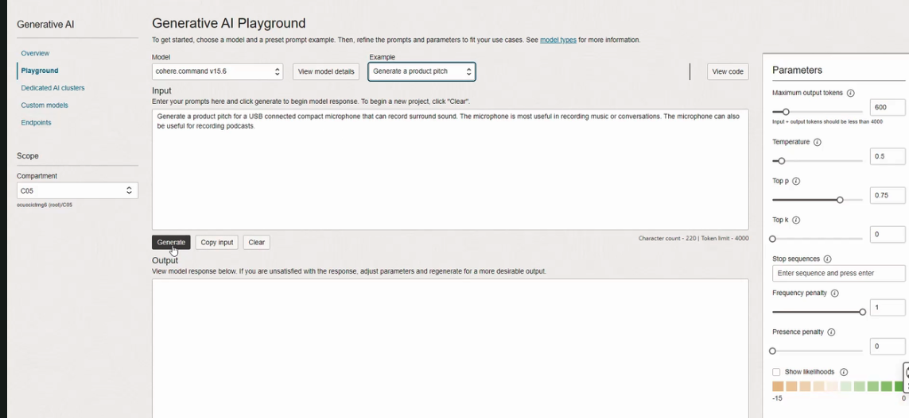

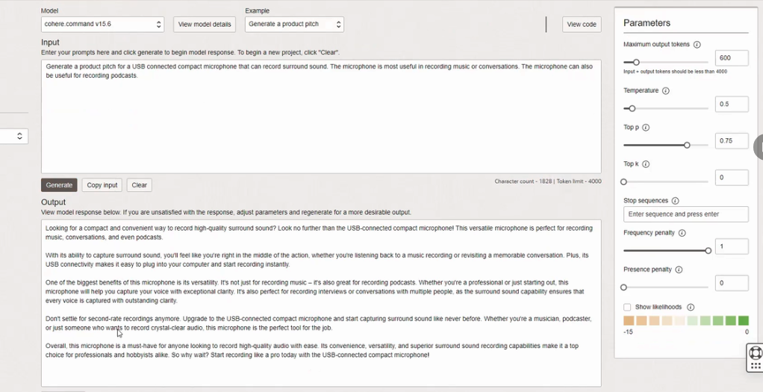

If I dn't like the result then change parameters and click generate. These will give new result. ( more creative answer)

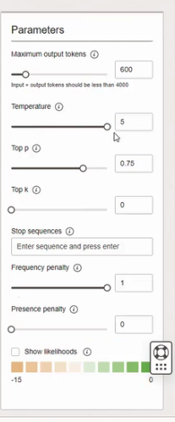

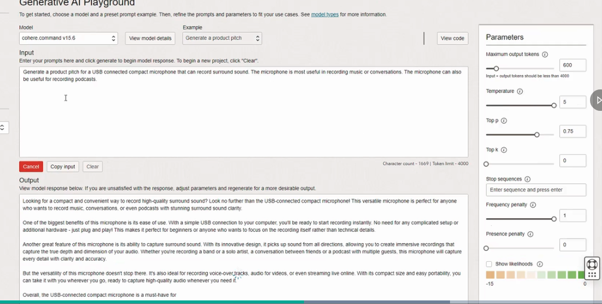

You can also change the models:

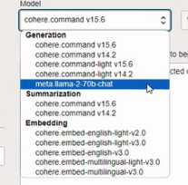

And can give the same prompt. the response will be different because used different model.

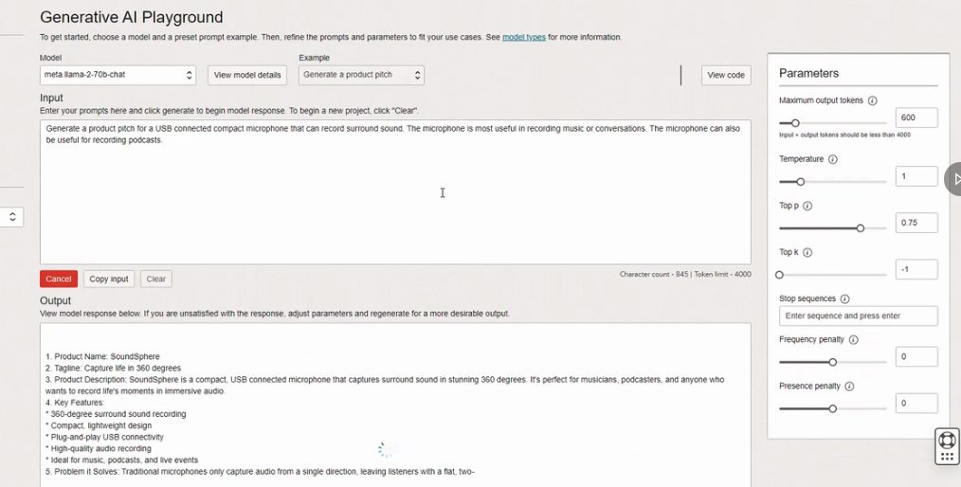

Once happy with the response you can view code. in Java or Python.

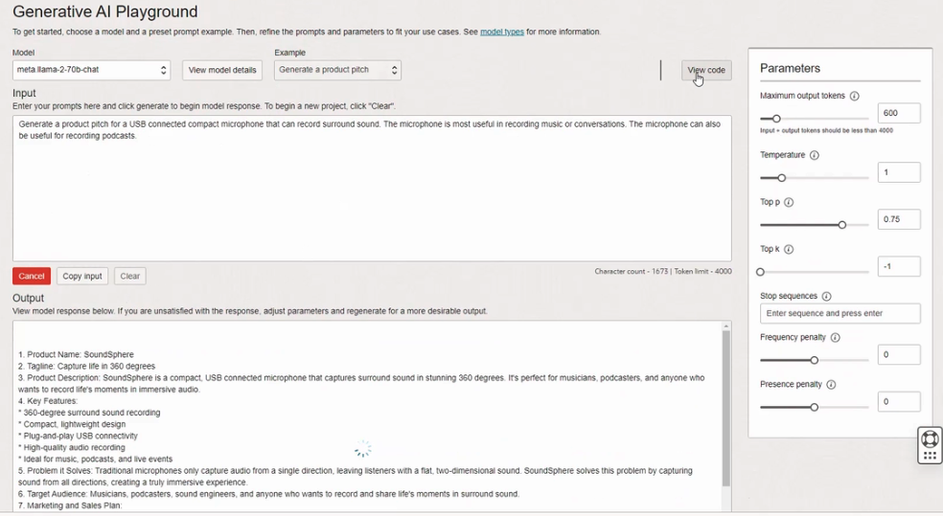

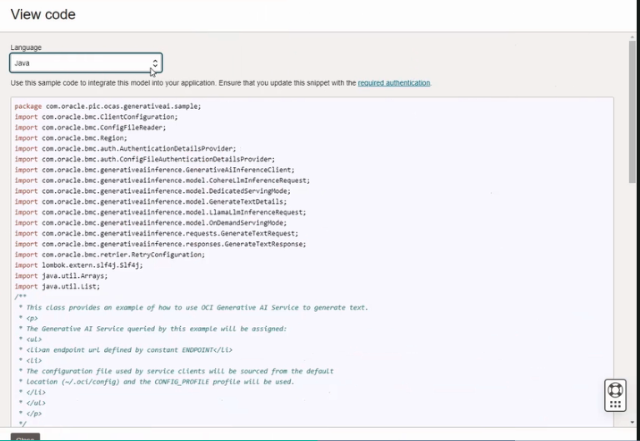

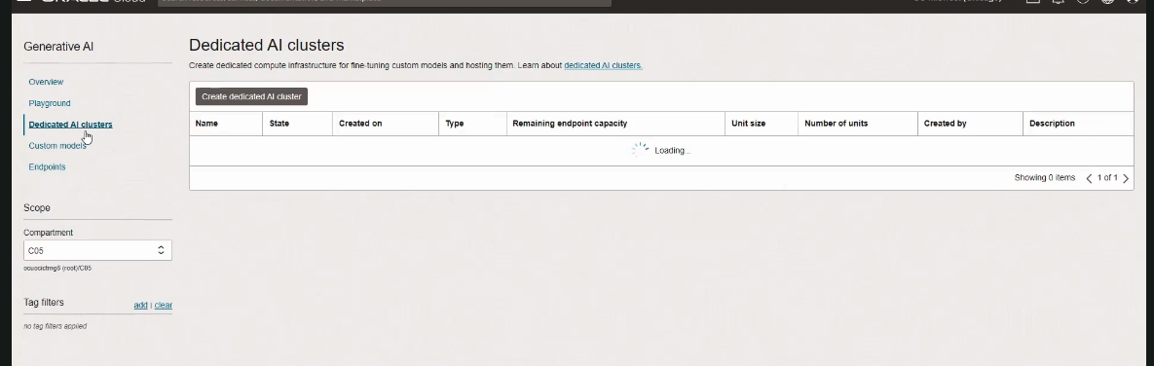

click dedicated AI cluster

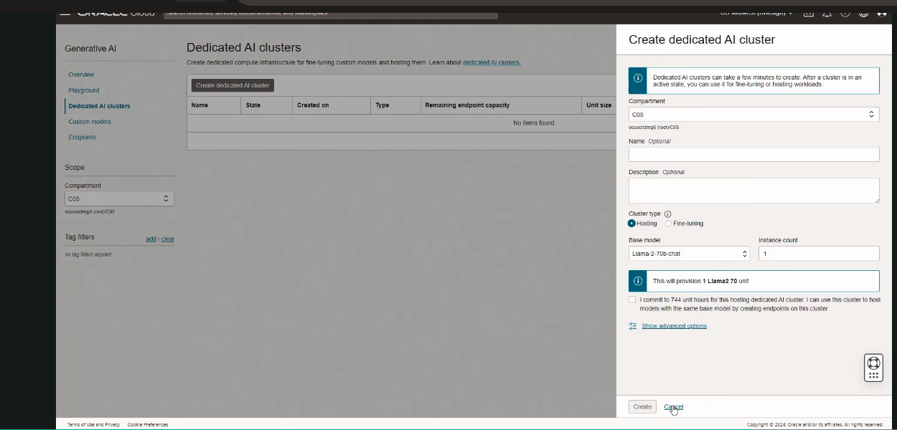

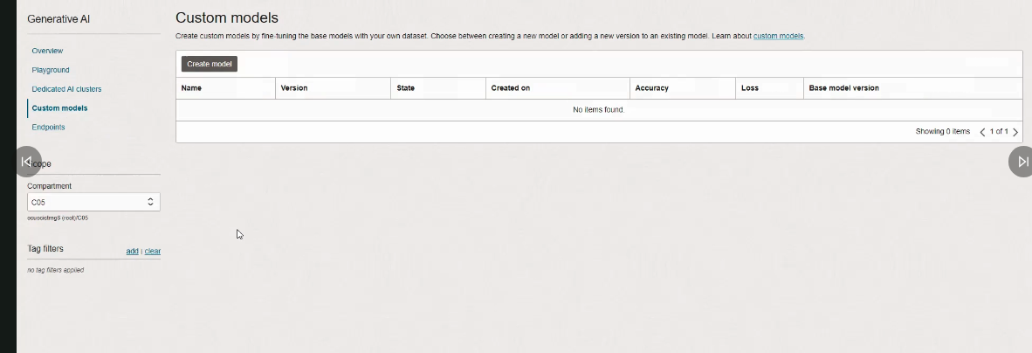

click create model

